**Exercise 3: File Analysis Tools**

**R. Harini**

**18BCE1010**

Algorithm / Procedure: Download and install Microsoft’s Log Parser tool for the Windows environment from Microsoft’s Web Site.

<https://www.microsoft.com/en-in/download/details.aspx?id=24659>

Tutorial Link: [Log Parser Tutorial: Learn to Parse Many Input Formats | Scalyr](https://www.scalyr.com/blog/log-parser-tutorial/)

**Output:**

1. LogParser “SELECT LogFileName as LineFromFile FROM C:\Windows\Logs\CBS\CBS.log

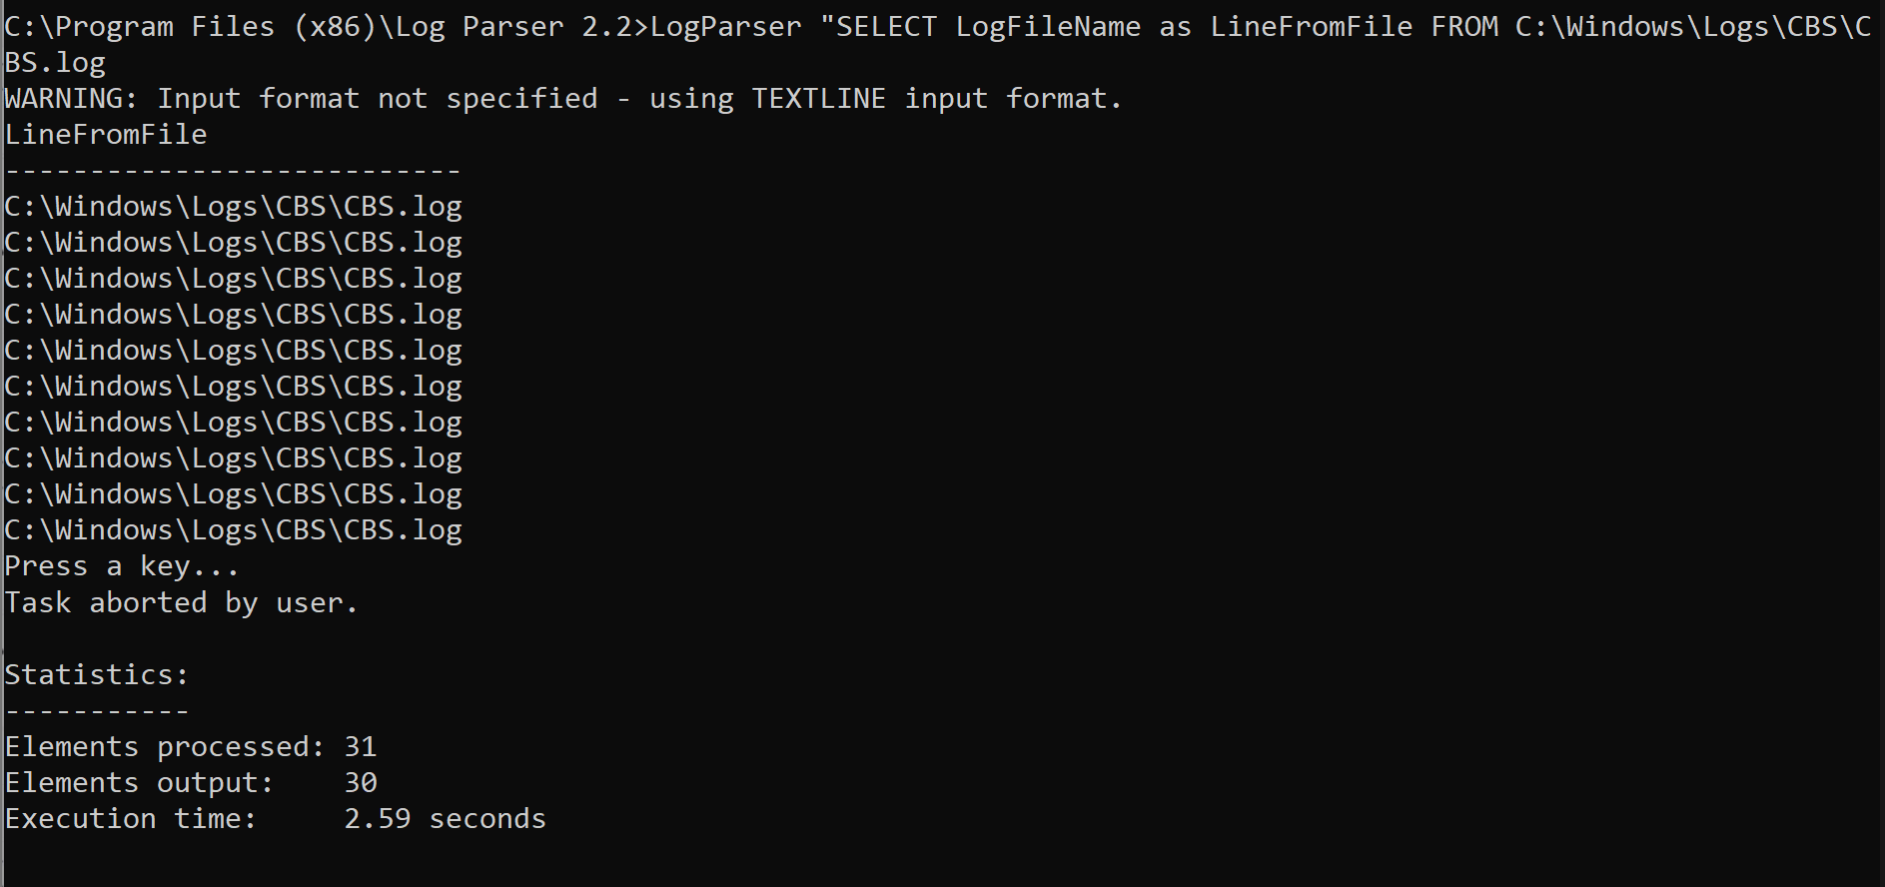

1. LogParser “SELECT Index as LineFromFile FROM C:\Windows\Logs\CBS\CBS.log

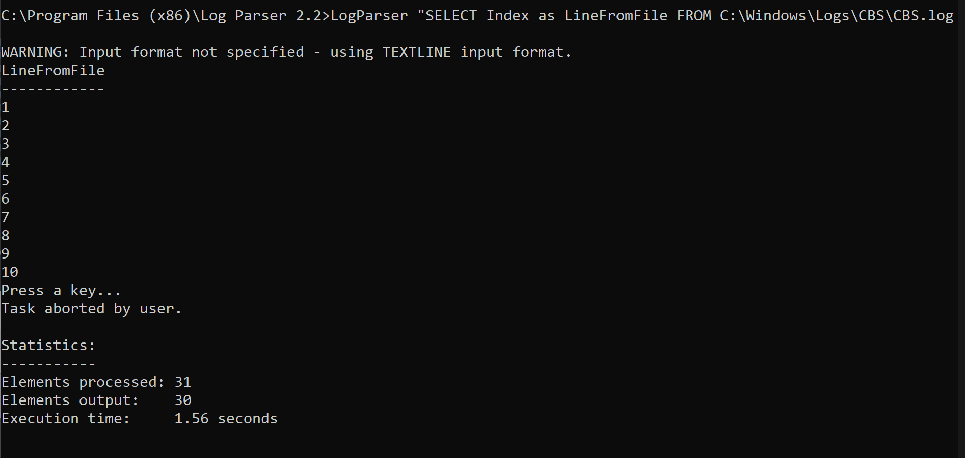

1. LogParser “SELECT Text as LineFromFile FROM C:\Windows\Logs\CBS\CBS.log

